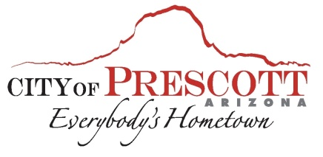

Prescott Business Showcase
Business Video Application

The Prescott Business Showcase is designed to help spotlight and promote your business in 3-5 minute videos put on by Robert Milligan from Arizona Communications Network. This is a new service being offered by the City of Prescott and the Prescott Chamber of Commerce made available to businesses at no additional cost. Please fill out the information below to schedule your business for its own showcase. Showcases will be promoted through the Prescott Chamber of Commerce and the City of Prescott channels. Videos will be made available to the business as well.

- Company Name___________________________________________________________

- Name/Title_______________________________________________________________

- Phone Number____________________________________________________________

- Email address_____________________________________________________________

- Website__________________________________________________________________

- Logo (JPEG or PNG format) __________________________________________________

- When did your business open?_______________________________________________

- Do you have any social media? _______________________________________________

- What do you like best about owning a business in Prescott? _______________________

________________________________________________________________________

- Are there any highlights you would like to discuss? _______________________________

_________________________________________________________________________

- Short bio of your company___________________________________________________

_________________________________________________________________________
_________________________________________________________________________

Return Form to Hunter Powell at the Prescott Chamber of Commerce 117 W. Goodwin St.
(928) 445-2000 ext. 117
hunter@prescott.org

